**CSE 212 – Programming with Data Structures**

**W01 Prove – Response Document**

|  |  |
| --- | --- |
| **Name:** | Eduardo Fernandez |
| **Date:** | 04/18/2023 |
| **Teacher:** | Brother Kunz |

*It is a violation of BYU-Idaho Honor Code to post or share this document with others or to post it online. Storage into a personal and private repository (e.g. private GitHub repository, unshared Google Drive folder) is acceptable.*

**Question 1: For the rotate right problem, provide a description of how you solved the problem.**

The first thing was to understand the logic requested, at first look the results provided don’t make sense because following the example, you think that starting with amount 5 means you start at number 5 because of the number value. Following this thinking there is no way that starting with amount 9 will return the array from 1 to 9 because it should start with 9 and end with 8.

After some minutes of thinking about this, I understood that the amount will give you the position. In the case of Amount 5, the program will list: from position -5 to the end (5 numbers) and from position 0 (beginning) to position 5 (4 remaining numbers).

Example:

Since Python can arrays counts backward, a -1 position returns the last number of the array.

Applying the logic with amount 5:

Using data[-5] returns [5]

If I add “:” after the “-amount”, python will return the remaining values starting from the position indicated. Otherwise, if I use it before the “-amount” it will return the values from the beginning of the array to the position indicated.

Using: data[-5:] returns [5,6,7,8,9] Using: data[:-5] returns [1,2,3,4]

If I concatenate both lists, I will get: [5,6,7,8,9,1,2,3,4]

Applying the same login with amount 1:

Using: data[-1:] returns [9] Using: data[:-1] returns [1,2,3,4,5,6,7,8]

Concatenated: [9,1,2,3,4,5,6,7,8]

Applying the same login with amount 9:

Using: data[-9:] returns [1,2,3,4,5,6,7,8,9] Using: data[:-9] returns []

Concatenated: [1,2,3,4,5,6,7,8,9]

**Question 2: For the rotate right problem, draw a picture of how you solved the problem.**

Example of the reversed position using amount 1:

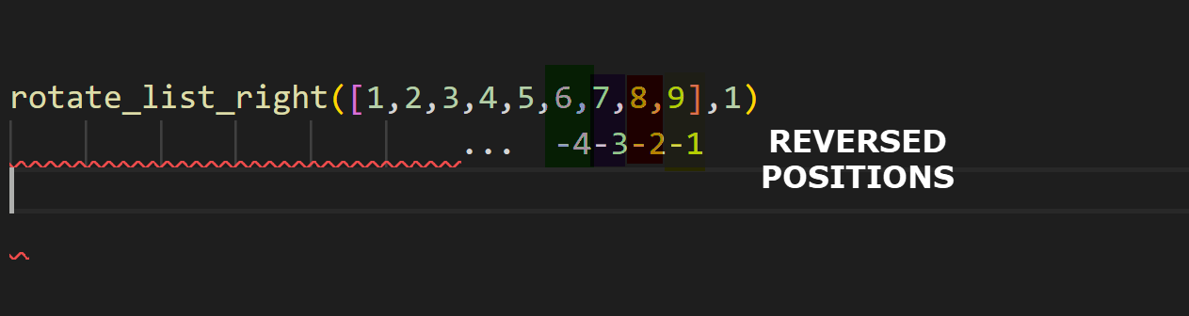

Here we can see how -1 becomes a 9 in value, from there to the end there is nothing else so that’s the only value returned on data[-1:] = [9]

And if the “:” are at the beginning, we get all the values before that position data[:-1] = [1,2,3,4,5,6,7,8]

Remember: You need to submit the following code files in addition to this document:

* 01-prove_multiples_of.py
* 01-prove_rotate_list_right.py